Name: Swikriti Shrestha Mark _____________________/50

Brief introduction __/3
This document describes the Enemy AI System for a top-down stealth-action game. The AI system is responsible for controlling enemy awareness, movement behavior, and combat engagement across the game’s levels. The AI operates using a state-based behavior model consisting of Stealth, Chase, and Attack states.
In Level 1 (Witch’s House), the AI supports stealth-focused gameplay by reacting to sound and light triggers without allowing enemies to attack the player. Once the pineapple is collected, enemies become alert and begin chasing the player. In Level 2 (Jungle Escape), the AI emphasizes pursuit and limited combat, allowing enemies to chase, search, and disengage based on player visibility. In Level 3 (Final Boss Arena), the AI immediately transitions into attack mode, enabling the boss fight mechanics.
The AI system integrates with the Level Design system for triggers and checkpoints and with the Boss Fight system for combat execution.

Use case diagram with scenario __14

Use Case Diagrams
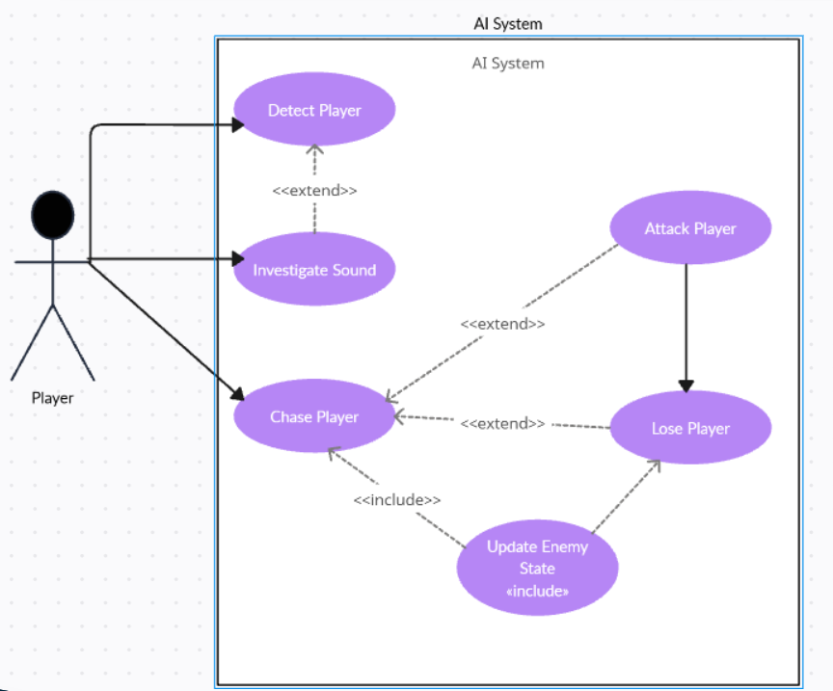
Scenarios
Name: Detect Player
Summary: The Enemy AI detects the player based on sound, lighting, or proximity.
Actors: Player
Preconditions:
- Player is inside the level.
- Enemy AI is active.
Basic sequence:
Step 1: Enemy AI monitors player position.
Step 2: Enemy AI listens for sound cues (floor cracking).
Step 3: Enemy AI checks player visibility based on lighting.
Step 4: Enemy AI updates detection status.
Exceptions:
- Step 2: Player does not generate sound → Enemy AI remains idle.
- Step 3: Player stays in darkness → Detection fails.
Post conditions:
- Detection status is updated.
Priority: 1
ID: AI01

Name: Investigate Sound
Summary: The Enemy AI moves toward a sound source created by the player.
Actors: Player
Preconditions:
- Player generates a sound event.
Basic sequence:
Step 1: Enemy AI receives sound location.
Step 2: Enemy AI moves toward the sound source.
Exceptions:
- Step 1: Sound occurs outside detection radius → No response.
Post conditions:
- Enemy position is updated.
Priority: 2
ID: AI02

Name: Chase Player (Triggered after Detect Player)
Summary: The Enemy AI chases the player after detection.
Actors: Player
Preconditions:
- Player has been detected.
Basic sequence:
Step 1: Enemy AI switches to chase state.
Step 2: Enemy AI follows the player’s position.
Exceptions:
- Step 2: Player escapes detection range → Extend Lose Player.
Post conditions:
- Enemy continues pursuit or exits chase state.
Priority: 1
ID: AI03

Name: Attack Player (<<extend>> Chase Player)
Summary: The Enemy AI attacks the player when within range.
Actors: Player
Preconditions:
- Player is within attack range.
Basic sequence:
Step 1: Enemy AI confirms attack range.
Step 2: Enemy AI executes attack behavior.
Exceptions:
- Step 1: Player moves out of range → Return to Chase Player.
Post conditions:
- Player health is reduced via combat system.
Priority: 1
ID: AI04

Name: Lose Player (<<extend>> Chase Player)
Summary: The Enemy AI loses the player and returns to stealth behavior.
Actors: Player
Preconditions:
- Enemy AI is chasing the player.
Basic sequence:
Step 1: Enemy AI checks visibility and sound input.
Step 2: Player is no longer detected.
Step 3: Enemy AI returns to patrol/stealth state.
Exceptions:
- Step 2: Player is re-detected → Return to Chase Player.
Post conditions:
- Enemy resumes stealth behavior.
Priority: 2
ID: AI05

Name: Update Enemy State (<<include>>)
Summary: The Enemy AI updates its internal state after behavior changes.
Actors: Enemy AI System
Preconditions:
- Enemy behavior changes.
Basic sequence:
Step 1: Enemy AI records current behavior state.
Step 2: Enemy AI saves updated state.
Exceptions:
- None.
Post conditions:
- Enemy state is stored for future logic.
Priority: 2
ID: AI06

Data Flow diagram(s) from Level 0 to process description for your feature _______14

Data Flow Diagrams
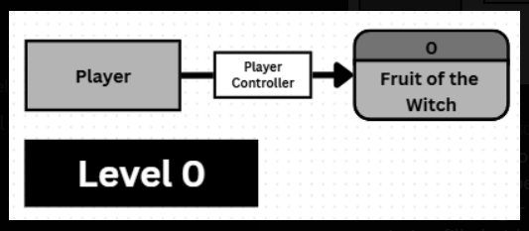
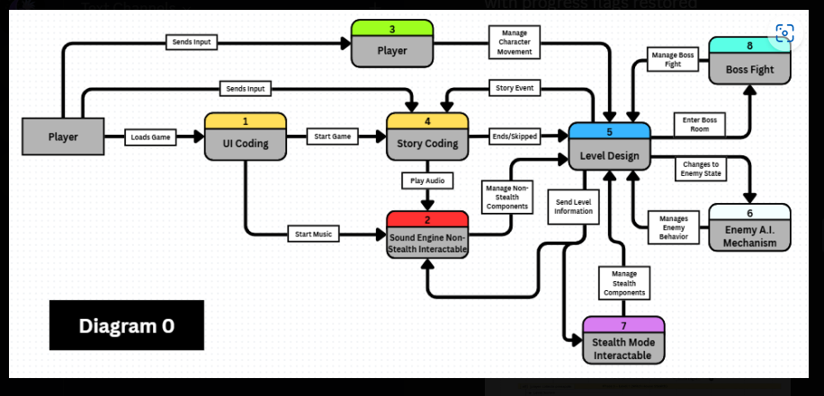

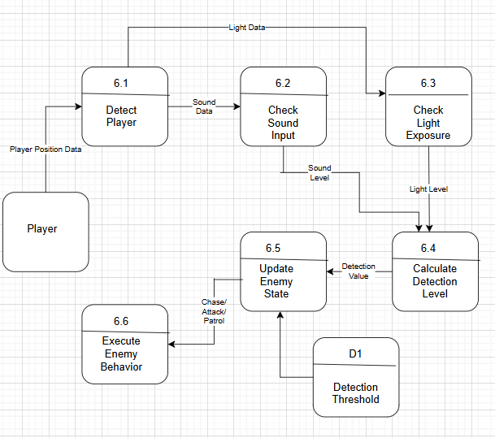

Process Descriptions
Processes (Enemy AI System)
  - Detect Player
Inputs:
• Player position
• Floor cracking sound
• Light exposure
Outputs:
• Detection status
  - Evaluate AI State
Inputs:
• Detection status
• Enemy state

Outputs:
• Stealth state
• Chase state
• Attack state
  - Execute Behavior
Inputs:
• AI state
• Player position
Outputs:
• Enemy movement
• Attack trigger
  - Update Enemy State
Inputs:
• Behavior result
Outputs:
• Updated enemy state.

Acceptance Tests ________9
Enemy AI Feature
Each test evaluates a single Enemy AI rule using deterministic inputs and expected outputs. Tests are designed to be automatable using Unity’s unit testing framework.
The output file will have the following characteristics:
- AI state is Stealth, Chase, or Attack
- No Attack in Level 1
- Chase above detection threshold
- Stealth below threshold
- Immediate Attack in boss arena
- Alert persists after pineapple
Unit Test Table — Enemy AI State Evaluation
Test ID | Detection Value | Level | Pineapple Collected | Expected AI State | Notes
UT-01 | 0 | Any | No | Stealth | No sound, no light
UT-02 | Threshold – 1 | Any | No | Stealth | Below boundary
UT-03 | Threshold | Any | No | Chase | At boundary
UT-04 | Threshold + 1 | Any | No | Chase | Above boundary
UT-05 | Threshold + 1 | Level 1 | No | Chase | Attack disabled
UT-06 | Threshold + 1 | Level 2 | No | Attack | Combat enabled
UT-07 | Any | Boss Arena | Any | Attack | Immediate attack
UT-08 | -1 | Any | No | Stealth | Invalid input clamped
UT-09 | Max + 1 | Any | No | Chase | Invalid input clamped
UT-10 | Any | Any | Yes | Chase | Alert persists
UT-11 | Any | Any | No | Stealth | Respawn without pineapple

Timeline _________/10

Work items- Enemy Ai System
Task | Duration (Phours) | Predecessor Task(s)
1. AI Requirements Analysis | 6 | -
2. Detection Logic Design (Sound & Light) | 8 | 1
3. Stealth Behavior Implementation | 8 | 2
4. Chase Behavior Implementation | 8 | 2
5. Attack Behavior Implementation | 10 | 3,4
6. Alert State Persistence (Pineapple Logic) | 4 | 3
7. Boss Fight AI Integration | 4 | 5
8. AI Testing & Debugging | 6 | 6,7
9. Documentation | 4 | 8

Pert diagram
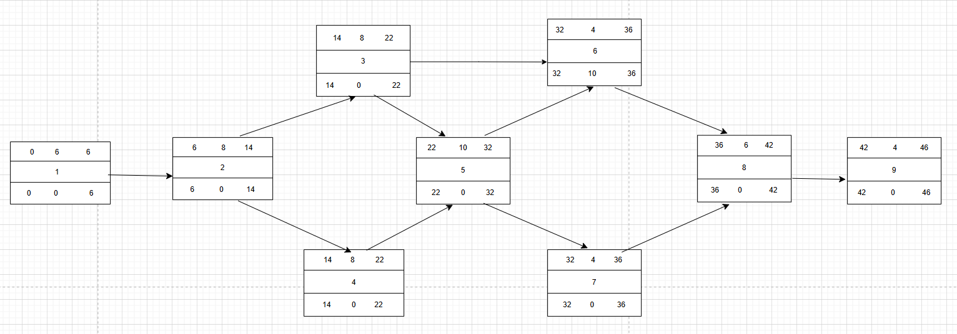

Gantt timeline
1
2
3
4
5
6
7
8
9
 | 2 | 4 | 6 | 8 | 10 | 12 | 14 | 16 | 18 | 20 | 22 | 24 | 26 | 28 | 30 | 32 | 34 | 36 | 38 | 40 | 42 | 44 | 46

